Project Report
On
Security Framework for IoT Devices

Submitted in partial fulfillment for the award of

Post Graduate Diploma in Internet of Things (PG-DIoT) from C-DAC, ACTS (Pune)


Guided by:
Mr. Sanyam Arya
Presented by:

Mr. Akash Erande Prn: 190240126003
Miss Nikita Bawane Prn: 190240126007
Mr. Sanket Desai Prn: 190240126008
Mr. Hemjyoti Kalita Prn: 190240126009
Ms. Pooja Sharma Prn. 190240126014

Centre for Development of Advanced Computing (C-DAC), Pune.

ACKNOWLEDGEMENT

This project “Security Framework for IoT Devices” was a great learning experience for me and I am submitting this work to Advanced Computing Training School (CDAC ACTS).
I am very glad to mention the name of Mr. Sanyam Arya for his / her valuable guidance to work on this project. His / Her guidance and support helped me to overcome various obstacles and intricacies during the course of project work.

I am highly grateful to Ms. Risha P.R. (Manager (ACTS training Centre), C-DAC, for her guidance and support whenever necessary while doing this course Post Graduate Diploma in Internet of Things (PG-DIoT) through C-DAC ACTS, Pune.

My heartfelt thanks goes to Ms. Namrata Ailwar (Course Coordinator, PG-DIoT) who gave all the required support and kind coordination to provide all the necessities like required hardware, internet facility and extra Lab hours to complete the project and throughout the course up to the last day here in C-DAC ACTS, Pune.

From:

Mr. Akash Erande (190240126003)
Miss Nikita Bawane (190240126007)
Mr. Sanket Desai (190240126008)
Mr. Hemjyoti Kalita (190240126009)
Miss. Pooja Sharma (190240126014)

TABLE OF CONTENTS

Abstract

1. Introduction of Project

2. Product Overview and Summary
2.1 Purpose
2.2 Scope
2.3 Overview
2.4 Feasibility Study

3. Overall Description
3.1 Product Feature
3.2 Technology Used
3.2.1 HARDWARE
a. Raspberry Pi 3 Model B
b. NodeMCU ESP8266
c. DHT11
3.2.2 SOFTWARE/LIBRARIES
a. Arduino IDE
b. Mosquitto
c. OpenSSL

3.3 General Constraints

4. Methodology
4.1 Problem Identification
4.2 Security in IoT
4.3 SSL/TLS
4.3 ESP8266 as an MQTT-enabled IoT Endpoint
4.3.1 Controlling LED
4.3.2 Reading DHT11 data
4.4 Diagram

5. Demo screenshots

6. Test Report

7. Future scope

9. References

ABSTRACT

IoT devices have many applications that are designed to make life easier and simpler. Engineers are able to access a device, perform remote diagnosis and remediate any issue. This is after the device has informed the engineering team of an impending issue before it becomes a major problem. Another example is being able to turn the lights on in your house or heating before coming home using your Smartphone.

With this data exchange over the internet comes security issues.

Security Framework for IoT devices is a security framework intended for clients looking to add a layer of security on their IoT project. This framework is for security, providing locking of data with the help of private keys and certificates created with the help of OpenSSL. The main feature of the framework is that it provides security against unaccounted third parties looking to tamper and change the data that is being sent from IoT node to the broker.

The private key ensured that only the clients subscribed will be able to access and change the data that is being sent from the IT node to the broker. If a third party does not have the private key or the fingerprint, they are not allowed to view the data. In this way the vulnerable data is being secured with the help of private keys and certificates that are generated with the help of OpenSSL.

1. Introduction of Project:

IoT is a network in which all physical objects are connected to the internet through network devices or routers and exchange data. IoT allows objects to be controlled remotely across existing network infrastructure. This technique also has autonomous control feature by which any device can control without any human interaction. “Things” in the IoT sense, is the mixture of hardware, software, data, and services. “Things” can refer to a wide variety of devices such as DNA analysis devices for environmental monitoring, electric clamps in coastal waters, Arduino chips in home automation and many other. These devices gather useful data with the help of various existing technologies and share that data between other devices. Examples include Home Automation System which uses Wi-Fi or Bluetooth for exchange data between various devices of home.

IoT devices have many applications that are designed to make life easier and simpler. Engineers are able to access a device, perform remote diagnosis and remediate any issue. This is after the device has informed the engineering team of an impending issue before it becomes a major problem. Another example is being able to turn the lights on in your house or heating before coming home using your smartphone.

With this data exchange over the internet comes security issues. Within the rest of this report we will highlight a few security issues with IoT devices and some suggested countermeasures.
Lack of transport encryption deals with data being exchanged with the IoT device in an unencrypted format. This could easily lead to an intruder sniffing the data and either capturing this data for later use or compromising the device itself. Specific security vulnerabilities that could lead to this issue include unencrypted services via the internet, unencrypted Services via the local network, poorly implemented SSL/TLS and misconfigured SSL/TLS.
In this project countermeasures are taken to protect against the threats. This project ensures data is encrypted using protocols such as SSL and TLS while transiting networks. It ensures other industry standard encryption techniques are utilized to protect data during transport if SSL or TLS are not available. Also ensures that only accepted encryption standards are used and avoid using proprietary encryption protocols.

2. Product Overview and Summary

2.1 Purpose:

This project is provide a security framework. Using this framework we encrypt the data being sent by IoT devices and protect it.

This document gives the brief summary of the security framework. It will be helpful in many fields to prevent leaking of important data.

2.2 Scope:

The Security Framework for IoT Devices is a framework to assist a user(individual or society) for making the IoT architecture more secure.

2.3 Overview:

Section 3.0, the Overall Description, provides an overview of the components and the relationship between them. Section 4.0 provides the Specific Requirements of the product. In the subsection (4.1) and (4.2) of which the various functional requirements and various interface respectively are discussed. Section 5.0 describes Database Design details.

2.4 Feasibility Study

Feasibility is determination of whether a projects worth doing or not. Before actually recommending the new system it is important to investigate if it is feasible to develop the new system.

Before developing and implementing a system we have sure that our system is feasible in the following ways:

1. Technical Feasibility.
2. Operational Feasibility.
3. Economical Feasibility.

- Technical Feasibility:

In the type of feasibility study, the system analyst has to check whether it is possible or not to develop the requested system with availability of manpower, software, hardware, etc…The system which we run in Linux and Raspbian are suitable for clients.

- Operational Feasibility:

In this type of feasibility study the operation implementation of the system is considered. Checking is done regarding whether it is feasible for the user department to use the framework. Thus the proposed system is said to be operationally feasible only if the clients are able to understand the system clearly and correctly and can use the system with ease.

- Economical Feasibility:

In this type of feasibility study, the benefits of the system to the organization are considered by taking into consideration the cost-benefit analysis. The basic software, which is required for the implementation of the system, is Linux which easily available. Also with the basic training user can use this software thus reducing the training cost to the organization. Thus, using this system is feasible for the organization and loading Linux and the proposed system is economically feasible for the organization.

3. Overall Description:

3.1 Product Features

The main feature of this system is to provide security for IoT devices. The security framework provides encryption and decryption of the data being sent and received from the IoT devices, respectively.

3.2 Technology Used

3.2.1 HARDWARE

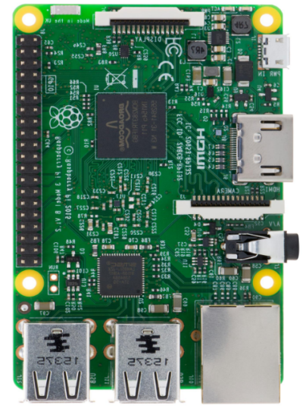
a. Raspberry Pi 3 Model B

The Raspberry Pi is a Broadcom BCM2835 SOC (system on chip board). It comes equipped with a 700 MHz, 512 MB of SDRAM and ARM1176JZF-S core CPU. The USB 2.0 port of the raspberry pi boars uses only external data connectivity options. The Ethernet in the raspberry pi is the main gateway to interconnect with other devices and the internet in model B. This draws its power from a micro USB adapter, with a minimum range of 2.5 watts (500 MA). The graphics, specialized chip is designed to speed up the manipulation of image calculations. This is in built with Broadcom video core IV cable that is useful if you want to run a game and video through your raspberry pi.

Features of Raspberry PI Model B
- 512 MB SDRAM memory
- Broadcom BCM2835 SoC full high definition multimedia processor
- Dual Core Video Core IV Multimedia coprocessor
- Single 2.0 USB connector
- HDMI (rev 1.3 and 1.4) Composite RCA (PAL & NTSC) Video Out
- 3.5 MM Jack, HDMI Audio Out
- MMC, SD, SDIO Card slot on board storage
- Linux Operating system
- Dimensions are 8.6cm*5.4cm*1.7cm
- On board 10/100 Ethernet RJ45 jack
The raspberry pi boards are used in many applications like Media streamer, Arcade machine, Tablet computer, Home automation, Carputer, Internet radio, Controlling robots, Cosmic Computer, Hunting for meteorites, Coffee and also in raspberry pi based projects.

b. NodeMCU ESP8266

Node MCU is an open source IoT platform. It’s the best platform for open source advocates. It is reasonably solid and predictable, especially given the low cost. NodeMCU is an open source IoT platform that uses the Lua scripting language. It's based on the eLua project, and built on the ESP8266 SDK. It uses many open source projects, such as lua-cjson, and spiffs. It includes firmware which runs on the ESP8266 Wi-Fi SoC from Expressif Systems and hardware.
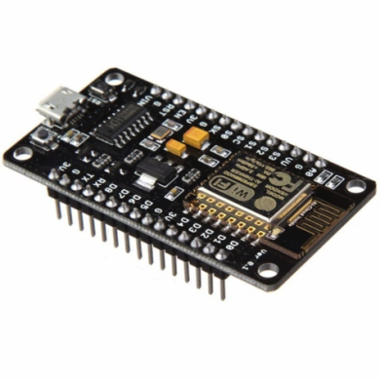
Benefits-
- Most affordable standard size ESP8266
- Multiple options available
- Open source, good documentation
- An Arduino-like device
- Main component: ESP8266
- With programmable pins
- And built-in Wi-Fi
- Power via USB

c. DHT11

The DHT11 is a commonly used Temperature and humidity sensor. The sensor comes with a dedicated NTC to measure temperature and an 8-bit microcontroller to output the values of temperature and humidity as serial data. The sensor is also factory calibrated and hence easy to interface with other microcontrollers.
The sensor can measure temperature from 0°C to 50°C and humidity from 20% to 90% with an accuracy of ±1°C and ±1%. So if you are looking to measure in this range then this sensor might be the right choice for you.

DHT11 Specifications:
- Operating Voltage: 3.5V to 5.5V
- Operating current: 0.3mA (measuring) 60uA (standby)
- Output: Serial data
- Temperature Range: 0°C to 50°C
- Humidity Range: 20% to 90%
- Resolution: Temperature and Humidity both are 16-bit
- Accuracy: ±1°C and ±1%
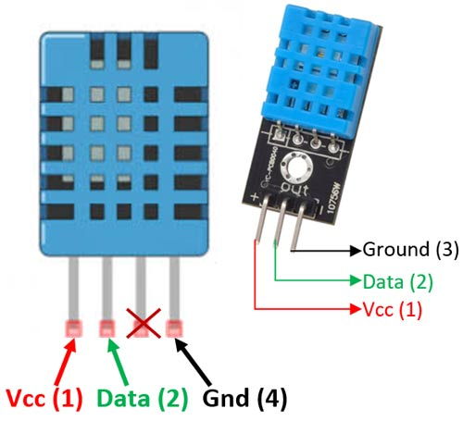
Applications:
- Measure temperature and humidity
- Local Weather station
- Automatic climate control
- Environment monitoring

3.2.2 SOFTWARE/LIBRARIES

a. Arduino IDE

The open-source Arduino Software (IDE) makes it easy to write code and upload it to the board. It runs on Windows, Mac OS X, and Linux. The environment is written in Java and based on Processing and other open-source software. This software can be used with any Arduino board. Arduino is a tool for making projects that can sense and control the physical world. It's based on a simple Arduino microcontroller board, and the 'Arduino development environment' for writing software for the board.
The Arduino microcontroller board can be used to accomplish virtually whatever task you may want to use it for. The board is almost like a mini computer, and, the way it reacts and controls the sensors and output device that you connect to it, is determined by the software that you develop and program the board with. The software could be very simple (e.g. flash an LED), or very complex, depending on what is required for your design. It is the software that controls the function of the hardware. The software is written in a 'C' type language. This is very simple for beginners to use, but, is also powerful enough to develop complex systems if required.

b. Mosquitto

Eclipse Mosquitto is an open source (EPL/EDL licensed) message broker that implements the MQTT protocol versions 5.0, 3.1.1 and 3.1. Mosquitto is lightweight and is suitable for use on all devices from low power single board computers to full servers.
The MQTT protocol provides a lightweight method of carrying out messaging using a publish/subscribe model. This makes it suitable for Internet of Things messaging such as with low power sensors or mobile devices such as phones, embedded computers or microcontrollers.
The Mosquitto project also provides a C library for implementing MQTT clients, and the very popular mosquitto_pub and mosquitto_sub command line MQTT clients.

c. OpenSSL

OpenSSL is a robust, commercial-grade, and full-featured toolkit for the Transport Layer Security (TLS) and Secure Sockets Layer (SSL) protocols. It is also a general-purpose cryptography library.

OpenSSL is licensed under an Apache-style license, which basically means that you are free to get and use it for commercial and non-commercial purposes subject to some simple license conditions.

OpenSSL is a general purpose cryptography library that provides an open source implementation of the Secure Sockets Layer (SSL) and Transport Layer Security (TLS) protocols.

The library includes tools for generating RSA private keys and Certificate Signing Requests (CSRs), checksums, managing certificates and performing encryption/decryption. OpenSSL is written in C, but wrappers are available for a wide variety of computer languages.

As of this writing, it’s estimated that 66% of all Web servers use OpenSSL. The OpenSSL toolkit is licensed under an Apache-style license.

c. Wireshark

Wireshark is a free and open-source packet analyzer. It is used for network troubleshooting, analysis, software and communications protocol development, and education. Originally named Ethereal, the project was renamed Wireshark in May 2006 due to trademark issues.

Wireshark is cross-platform, using the Qt widget toolkit in current releases to implement its user interface, and using pcap to capture packets; it runs on Linux, macOS, BSD, Solaris, some other Unix-like operating systems, and Microsoft Windows. There is also a terminal-based (non-GUI) version called TShark. Wireshark, and the other programs distributed with it such as TShark, are free software, released under the terms of the GNU General Public License.

3.2 User Classes

This security framework can be used by anyone who wishes to add security to their project to block access from unknown third parties.

3.3 General Constraints

The “Security Framework for IoT Devices” should ensure encryption of information being dealt with in an IoT project and to prevent tamper or leakage of data.

4. METHODOLOGY

4.1 Problem Identification:-

Data privacy and security continues to be the single largest issues in today’s interconnected world. Data is constantly being harnessed, transmitted, stored and processed by large companies using a wide array of IoT devices, such as smart TVs, speakers and lighting systems, connected printers, HVAC systems, and smart thermostats.

Since many IoT devices lack even the most basic cyber security protections, such as strong default passwords, they often leave any interconnected systems vulnerable. Everything from a traffic grid to a public water supply system that gets hooked up with IoT devices could be hacked and manipulated with devastating consequences. When these events happen with greater frequency, and greater impact, it is likely we'll see calls for robust IoT device security standards in addition to any number of policy measures to mitigate the risks posed to publicly and privately own critical infrastructure.

4.2 Security in IoT:-

Besides gigantic importance and wide applications of IoT, It is not easy to deploy it in mission critical application areas, where security and privacy is of most important concerns. For example a successful security attack on smart healthcare system can cause in loss of many lives of patients, whilst it can also cause in financial loss, and loss of human lives in case of intelligent transportation system. Security of IoT is a challenging area and require further research work to cope with these challenges.

To keep the data confidential and secure in cloud it must be secure from breaches. This can be done by using tools to detect data migration from cloud, data loss prevention tools, file and database activity monitoring. Data dispersion and data fragmentation can also be used for Data security in cloud.

Security is the basic requirement of any user of digital media. An internet user will not share his confidential and important data on the network unless the network is trusted. With the emergence of cloud computing the security demands of its user also increased as they have to trust on third person owned cloud. For cloud vendors to attract more users to use their services they need to build user trust through cloud audits and Certification of compliance to CSA security standards or other standards of security. Although legacy network security solutions are mature enough but it is not feasible to apply it in the context of IoT due to the size of IoT networks heterogeneity in its architecture and resource constrained IoT end nodes.
4.3 Secure Sockets Layer (SSL) and Transport Layer Security (TLS):-

OpenSSL is used to generate our CA certificates and a key, and a server certificate for our MQTT broker.

In order to generate x509 certs, you have a couple of options:
- Get your own CA cert via a reputable cert signing authority like ‘Let’s Encrypt’
- Self-sign a cert
- Create your own self-signed CA and use that to sign a cert for your MQTT broker (and any other services) to use

Our plan is to not have our MQTT broker exposed to the outside world. So we have used option 2 and 3 here. The benefit of option 3 is that we can have a single self-signed cert to put is any of our devices that will need to access the MQTT broker. We have used an elliptical curve key using the secp521r1 curve. First, we generate a private key. Using this private key we generate a CA certificate.

When we set up our ESP8266 to connect to the MQTT Broker, in addition to using our CA cert to validate the MQTT broker’s cert, we’ll also want to validate the MQTT broker cert’s SHA1 fingerprint as well. This lets us know we’re seeing the right cert we’ve just generated and not some other cert signed by the CA, which could be malicious. The ESP8266WiFi class only supports SHA1 fingerprint matching.

4.3 ESP8266 as an MQTT-enabled IoT Endpoint

We are using Arduino Client for MQTT to talk to our MQTT broker from the ESP8266 device. We add include our base64-encoded PEM format CA cert and MQTT broker cert’s SHA1 fingerprint for validation. We also include a byte array to match against the MQTT broker cert SHA1 fingerprint extracted, and some globals needed by the WiFiClientSecure class to establish secure connections using the supplied CA cert and MQTT broker cert fingerprint.

We chose to use the functions allowSelfSignedCerts () and setFingerprint (…), which added some redundant security checks. We did not use setInsecure, because it bypasses both CA cert validation, and does not require a fingerprint check either, so we would have no idea where the connection is being made if someone changed the device at the other end of your connection without your knowledge.

A code is added which adds some random characters to the clientId each time the device is rebooted. A unique ID can also be provided to each board using the MAC address or some other mechanism if we prefer.

4.3.1 Controlling LED

A JSON format is used to send messages to the device through the broker to control the LED.

The expected behavior here is that someone can publish to the home/recroom/tv/powerstrip/cmd topic with JSON messages in the form of either:

- {"set" : "toggle"}, {"set" : "on"}, {"set" : "off"}
  - These will toggle, explicitly turn on, or explicitly turn off the control pin, respectively
  - These will also return the current pin status at the topic path home/recroom/tv/powerstrip/status as “on” or “off” after the pin status has been modified according to the incoming command

- {"get" : "status"}
  - This will return the current pin status at the topic path home/recroom/tv/powerstrip/status as “on” or “off”

4.3.2 Reading DHT11 data

A similar method is used to read the temperature and humidity values from the DHt11 sensor. We use Mosquitto to subscribe to a topic through the broker. The ESP8266 encrypts the data with the key and sends the encrypted data to the broker.

The broker checks the CA certificate and fingerprint used to encrypt the data. If the certificate and finger matches the private key in the broker, it decrypts the data. We subscribe to the topic and port mentioned in the device with Mosquitto and receive the decrypted data.

4.4. Packet sniffing with Wireshark

Wireshark was used to analyze the packets. We have used it to detect the attack. When SSL/TLS is used the hacker cannot view the data that is transmitted from the subscriber to the broker, or vice versa.

4.5 Diagram

IoT NODE

CONTAINS PUBLIC KEY
AND FINGERPRINT

RASPBERRY PI
(BROKER)

CONTAINS PRIVATE KEY
CREATED WITH OPENSSL

SUBCRIBER 1
WITH PRIVATE KEY
(WILL BE ALLOWED TO ACCESS DATA)
SUBSCRIBER 2
WITHOUT PRIVATE KEY
(WILL NOT BE ABLE TO ACCESS DATA)

- Demo Screenshots:

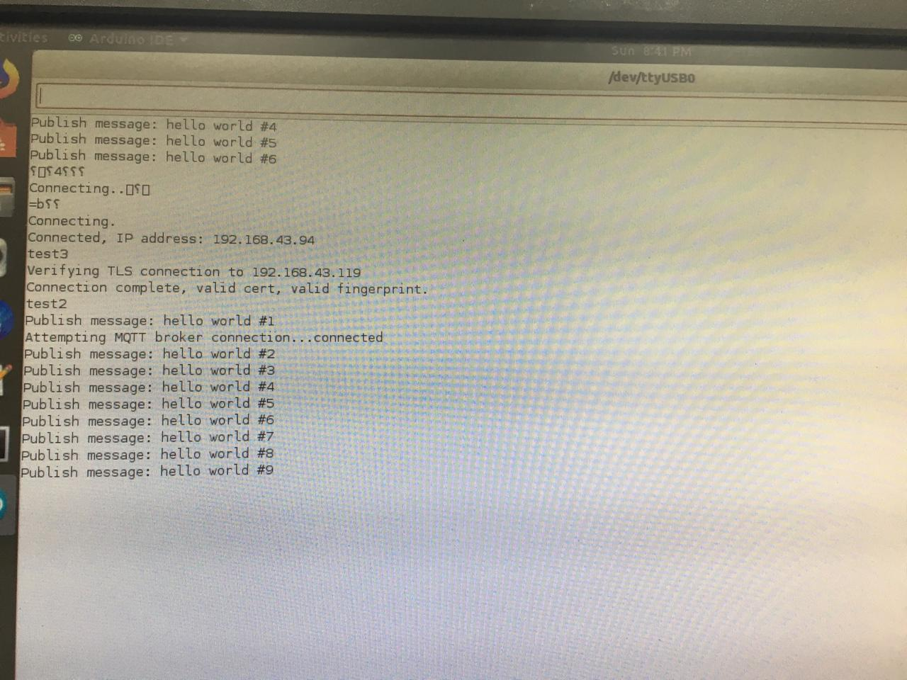
Figure 1-Data sent from IoT Device

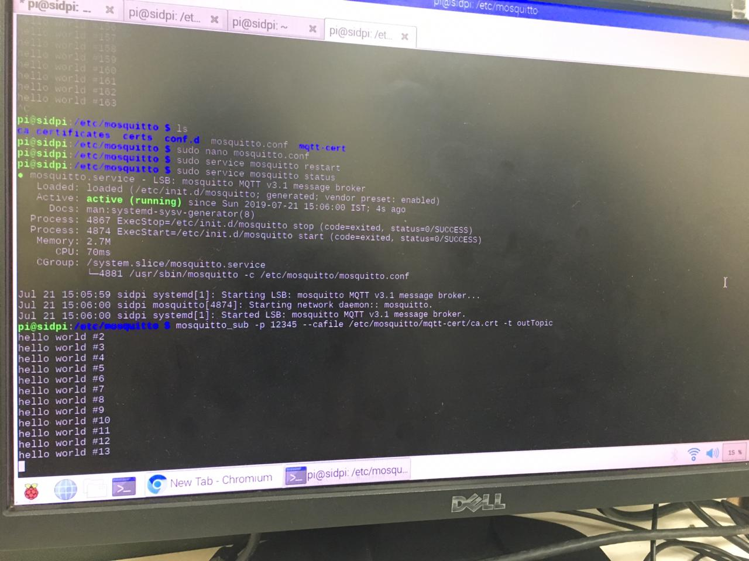
Figure 2- Data received at Broker
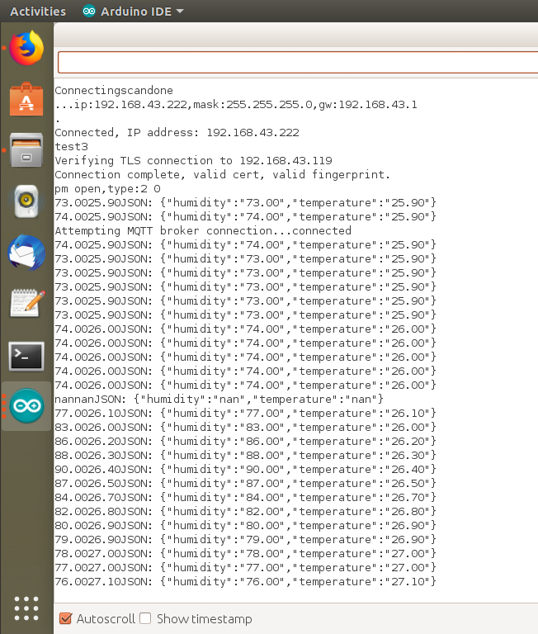
Figure 3- DHT11 data sent from IoT Device

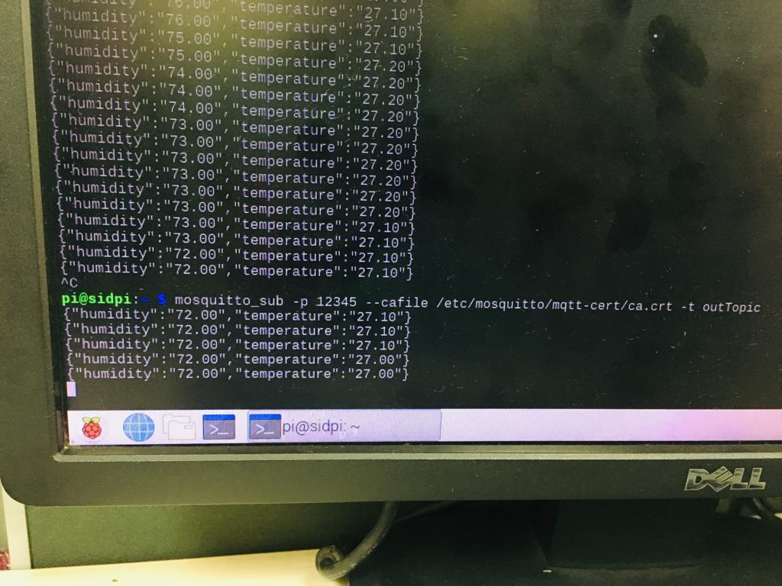
Figure 4- DHT11 data received by Broker

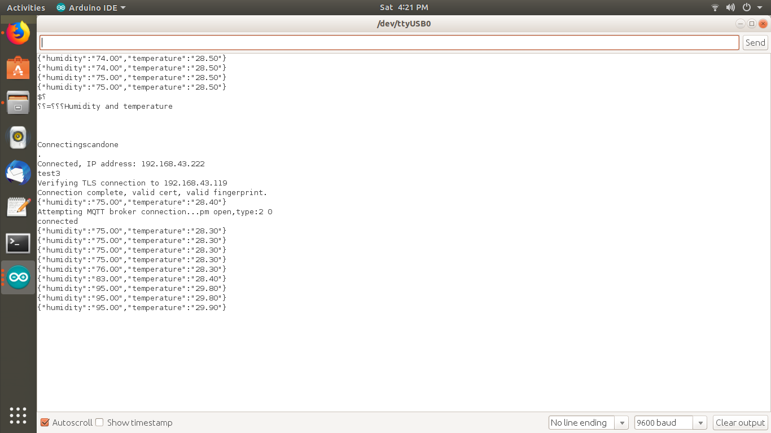
Figure 5- DHT11 data sent to subscriber

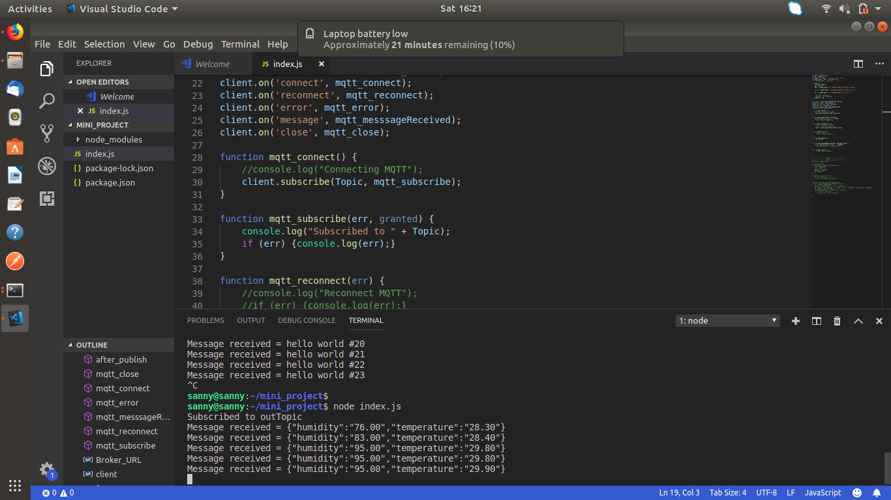
Figure 6- DHT11 data received by subscriber

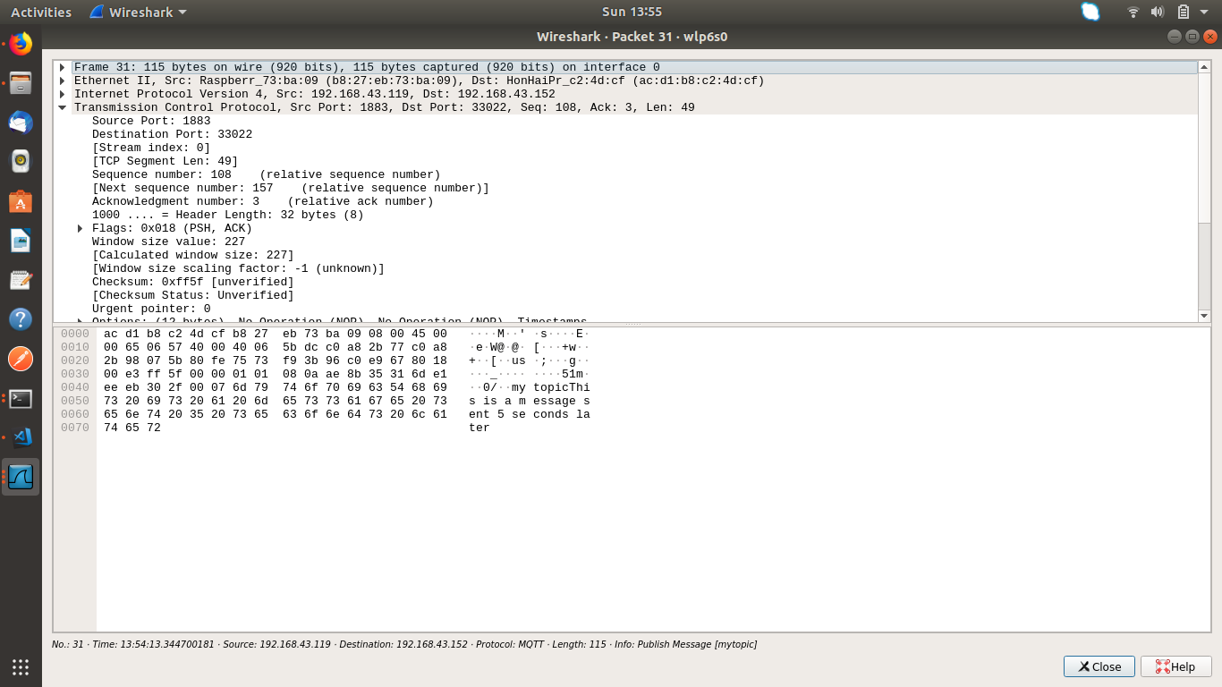
Figure 7- Wireshark used without the use of SSL/TLS

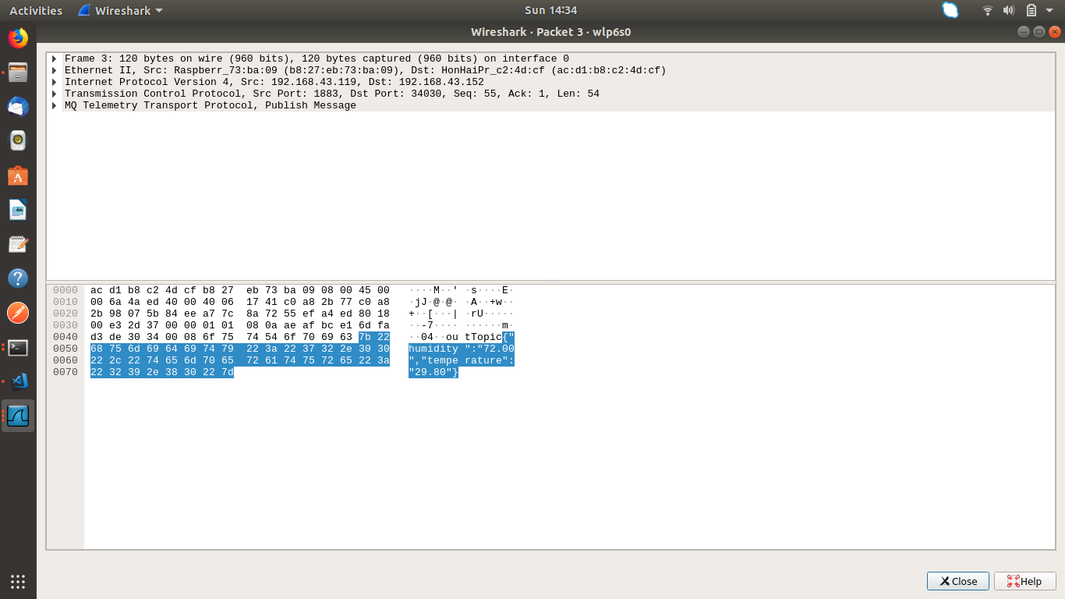
Figure 8- Data from DHT11 is visible

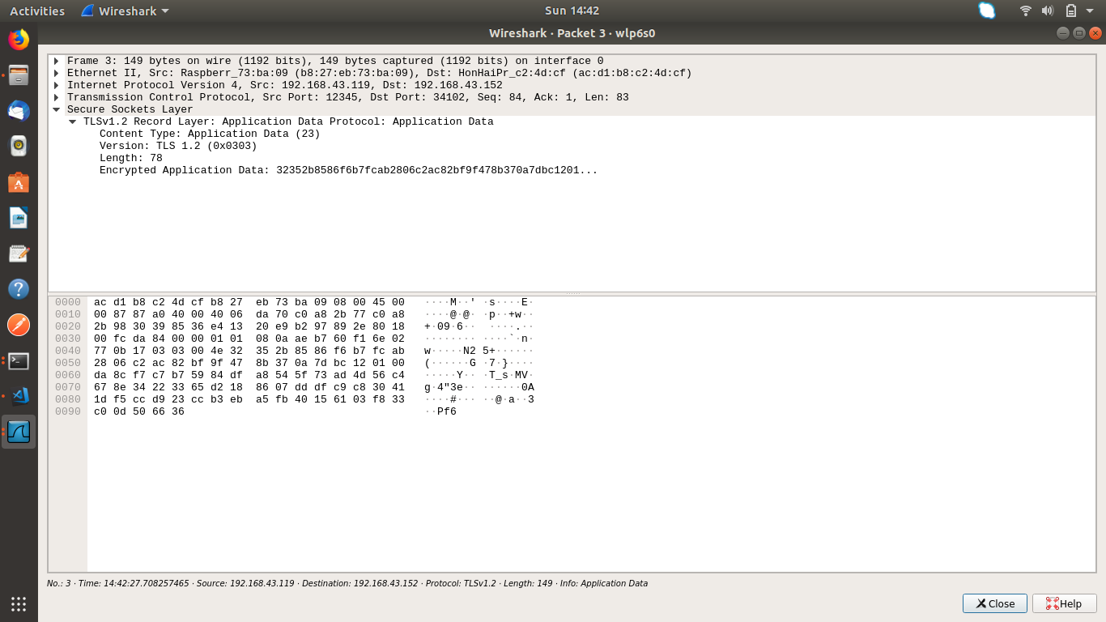
Figure 9- With the use of SSL/TLS data is not visible

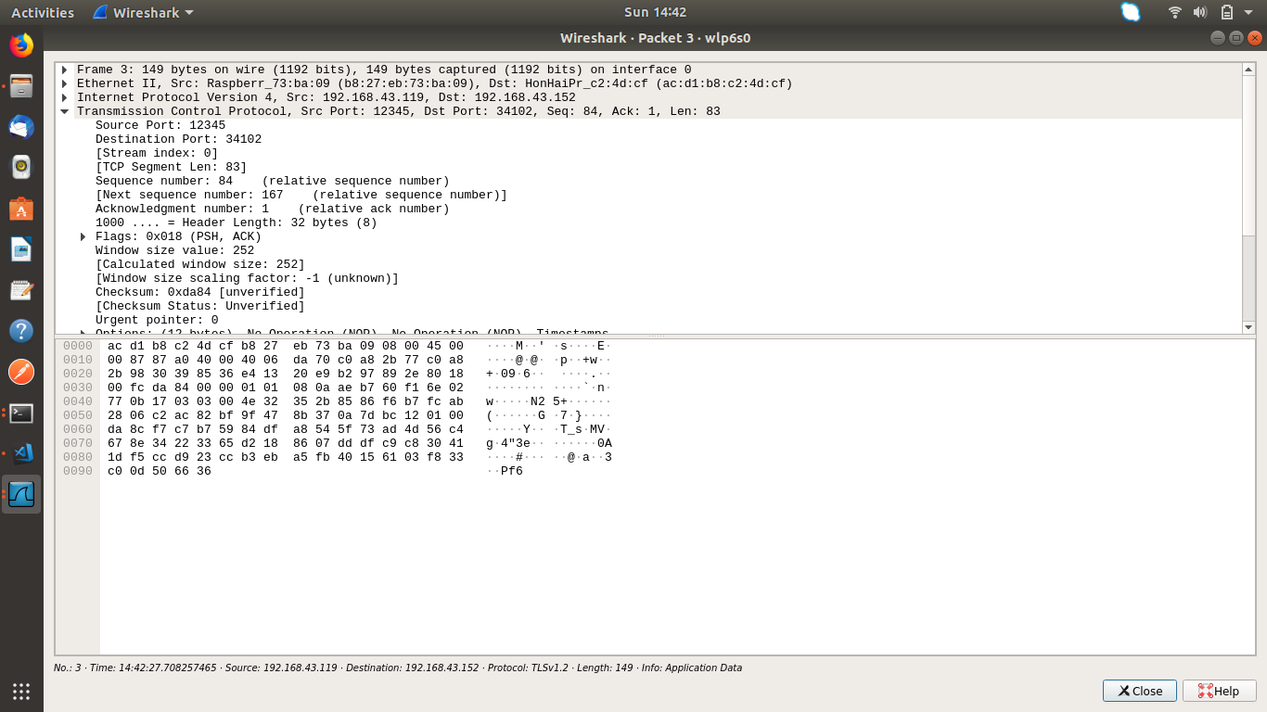
Figure 10- The data sent from DHT11 is not visible
6. TEST REPORT

Sr. No | Test Case Title | Description | Expected Outcome | Outcome | Result
1 | Create private key and certificate | Private key and certificate for authentication | Only the devices with the public key and certificate should be allowed to make connection | No error message. Connection simply not allowed. | Passed
2 | User name and password in Mosquitto | User name and password to given to Mosquitto | If Validated allow for messaging | No connection is made | Passed
3 | User subscribe without CA cert file | User tries to subscribe without certificate. | Permission Denied | Permission Denied | Passed
4 | Use Wireshark to analyze the security of communication. | Check with Wireshark if third party can hack in to the data being sent. | With SSL/TLS the data is not visible. | Data is not shown. | Passed
5 | Use Wireshark to analyze the security of communication. | Check with Wireshark if third party can hack in to the data being sent. | Without SSL/TLS the data is visible. | The message, port and title are shown. | Passed.

8. FUTURE SCOPE:

- We will be able to provide a more secure framework for the clients by uploading the data to cloud.

- Framework to be integrated into non-IP based protocols like UART, CAN and MODBUS.

9. REFERENCES:

- Internet of Things Security, Device Authentication and Access Control: A Review
By Inayat Ali , Sonia Sabir , Zahid Ullah
https://arxiv.org/ftp/arxiv/papers/1901/1901.07309.pdf

- The Bionic Cyclist
https://the-bionic-cyclist.co.uk/2017/03/22/setup-ssl-on-a-raspberry-pi-in-2-minutes/

- https://pdfs.semanticscholar.org/1047/1f4a68049e915e9d9a0ee914a0540f285e99.pdf

